752 S1 Supplemental Information

# 753 S1.1 Process Based Equations

754

Suppose you have a temporal step size ∆*t >* 0 and a age step size of  1

for all age

755 stages *i* = *E, LP, A*1*, A*2*, A*3*, A*4. Then for *t >* 0 and 0 ≤ *a* ≤ 1 the population *Ut* =

*N*

*i*

756 [*ut*(0)*, ut*(1*/N* )*, . . . , ut*(*a*)*, . . . , ut*(1)] can be updated from *Ut−*1 using the following process:

*i i i i* *i*

757 1. Apply Environmental Mortality

1. Freezing Events

If *i* = *E, LP* and *Tc <* 0 *ut*(*a*) = 0

*i*

1. Apply density dependent mortality (depending on water availability) to LP

*ut−*1(*a*)

*LP*

*t*

*uLP* (*a*) = 1 + *δ* ∆*t* Σ

*N*

*LP*

*a*

*ut−*1(*a*)

1. Apply temperature dependent mortality to Adults *i* = *A*1*, A*2*, A*3*, A*4

*ut*(*a*) = *ut−*1(*a*) exp(−*δAD*∆*t*)

*i*

*i*

758 2. Adjust age distributions

1. Calculate the developmental velocity for time *t*.

*vE*(*t*)*,* if *i* = *E.*



If *Tc < Tmin Vi*(*t*) = *vLP* (*t*)*,* if *i* = *LP.*

*vA*(*t*)*,* if *i* = *A*1*, A*2*, A*3*, A*4*.*

Else *Vi*(*t*) = 0

1. Shift individuals in age domain for *i* = *E, LP*

*ut*(*a* + *Vi*(*t*)∆*t*) = *ut−*1(*a*)

*i* *i*

1. Stochastically shift Adults in age domain *i* = *A*1*, A*2*, A*3*, A*4

*M* ∼ Γ(*vAD*(*t*)∆*t,* 1)

*ut* = *ut−*1 ∗ *M*

*i*

*i*

1. Adults switching stages and not in diapause lay eggs into first bin of Egg age domain

*g*1 = *ut* (*a >* 1)*, g*2 = *ut* (*a >* 1)*,*

*AD*1

*AD*2

*g*3 = *ut* (*a >* 1)*, g*4 = *ut* (*a >* 1)

*AD*3 *AD*4

*ut* (0) = Ovi*rate*(1 − *diapprob*)(*g*1 + *g*2 + *g*3 + *g*4)

*E*

1. Move individuals at end of age range to the first bin of next age stage.

Σ *ut*(*a >* 1) = *ut*

*i*

*i*+1

(0)

759 For our simulations *N* = 100 and ∆*t* = 1 day.

# 760 S1.2 Additional Figures and Tables

|  |  |  |  |  |  |
| --- | --- | --- | --- | --- | --- |
| Stage | Temp(*◦C*) | Development  Time(days) | Stage | Temp(*◦C*) | Development  Time(days) |
| Eggs | 15.0 | 3.5 | Adults | 11.7 | 17.5 |
| 17.0 | 3.2 | 12.4 | 16.1 |
| 20.0 | 2.5 | 17.3 | 8.3 |
| 23.0 | 2.0 | 15.4 | 10.8 |
| 25.0 | 1.9 | 16.0 | 9.0 |
| 30.0 | 1.3 | 20.6* | 4.7 |
| Larvae & Pupae | 15.0 | 27.1 | 21.0 | 5.0 |
| 17.0 | 16.0 | 16.3 | 12.4 |
| 20.0 | 11.6 | 30.0 | 3.5 |
| 22.0 | 11.5 | 25.0 | 4.8 |
| 25.0 | 7.0 | 22.0 | 5.6 |
| 30.0 | 6.9 | 20.0 | 6.1 |
|  | | | 17.0 | 15.2 |

Table S1: Lab and Field study values used to parameterize the temperature developmental time parameters for the Egg, Larval/Pupal, and Adult stages. The data for eggs can be found in Table 3, the combined Larval and pupal data can be found in Table 6, the adult developmental time in Table 11 of Madder et al. (1983). Note that the table order reflects the order of the source table. In particular the Adult data comes from both field and laboratory studies.

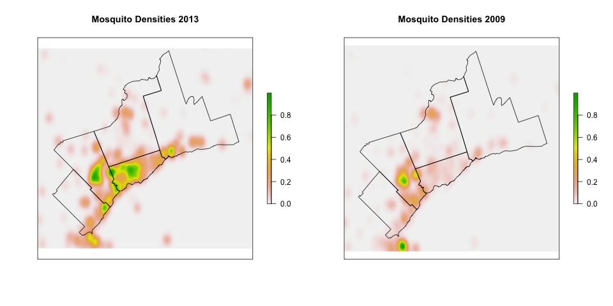

* 1. (b)

Supplemental Material, Figure S1: Figure S1(a) is a kernel density estimate of mosquito density in a flood year (2013). Figure S1(b) is a kernel density estimate of mosquito density in a non-flood year (2009)). Flooding often results in higher mosquito trap counts in a wider range of spatial locations in the area, providing motivation for using water levels in addition to temperature for capturing year-to-year changes in mosquito density.

|  |  |
| --- | --- |
| Temp (*◦C*) | Longevity  (days) |
| 16.00 | 86.89 |
| 20.00 | 111.99 |
| 24.00 | 43.07 |
| 28.00 | 35.21 |
| 32.00 | 24.34 |

Table S2: Data used to parameterize the linear model for temperature dependent Adult longevity. These values are derived from Figure 2 of Ciota et al. (2014).

**Data Trends: Mosquito counts, Temperature and Precipitation Data Trends: Mosquito counts, Temperature and Precipitation**

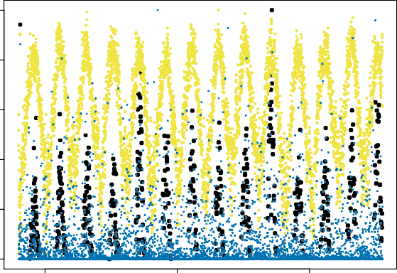

Mosquito abundance

Temperature Precipitation

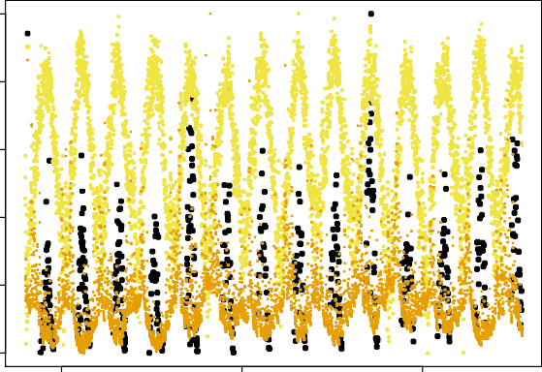

Mosquito abundance Temperature

Water Level

Normalized Values

0.6

0.8

1.0

Normalized Values

0.6

0.8

1.0

2005 2010 2015

0.0

0.2

0.4

Year

(a)

2005 2010 2015

0.0

0.2

0.4

Year

Supplemental Material, Figure S2: In Figure S2(a) observed mosquito abundance (black), temperature data (yellow) and precipitation measurements (blue) are shown. In Figure S2(b) observed mosquito abundance (black) temperature data (yellow) and water station measurements (orange). Initial analysis of the data (Figure S2) indicated that water station level measurements might be a better signal to capture the seasonal fluctuation of mosquito abundance in Toronto than precipitation measurements.

40



30

Average Mosquito Count in GTA

20

10

0

2004 2005 2006 2007 2008 2009 2010 2011 2012 2013 2014 2015 2016 2017

Year

Supplemental Material, Figure S3: A box and whiskers plot (identifying the 1st and 3rd quartiles, median and outliers) of the arithmetic mean of mosquito counts per trap per year in the Greater Toronto Area.