SUPPLEMENTAL MATERIAL

Habitat quality and nest-box occupancy by five species of oak woodland birds

Megan Milligan^{1,2}* and Janis L. Dickinson^{1,2}

¹ Department of Natural Resources, Cornell University, Ithaca, New York, USA
² Cornell Lab of Ornithology, Ithaca, New York, USA
* Corresponding author: megan.milligan11@gmail.com

SUPPLEMENTAL MATERIAL

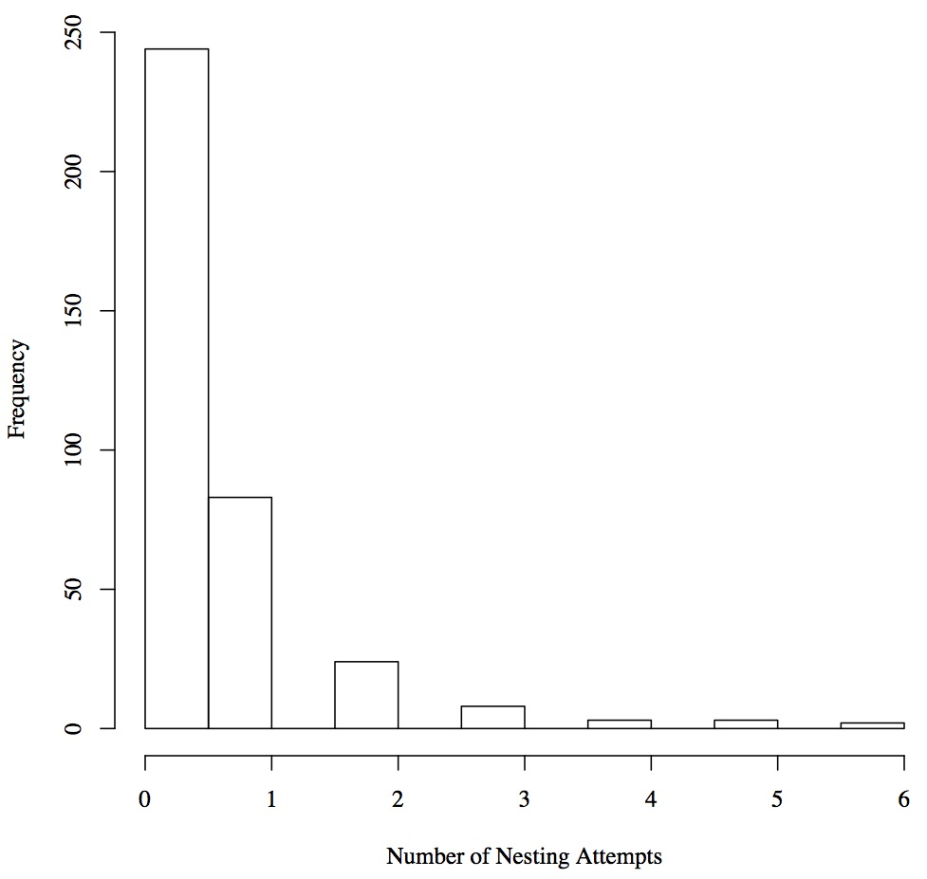
Figure S1. Distribution of the frequency of nesting attempts in a single box by Ash-throated Flycatchers in each box.

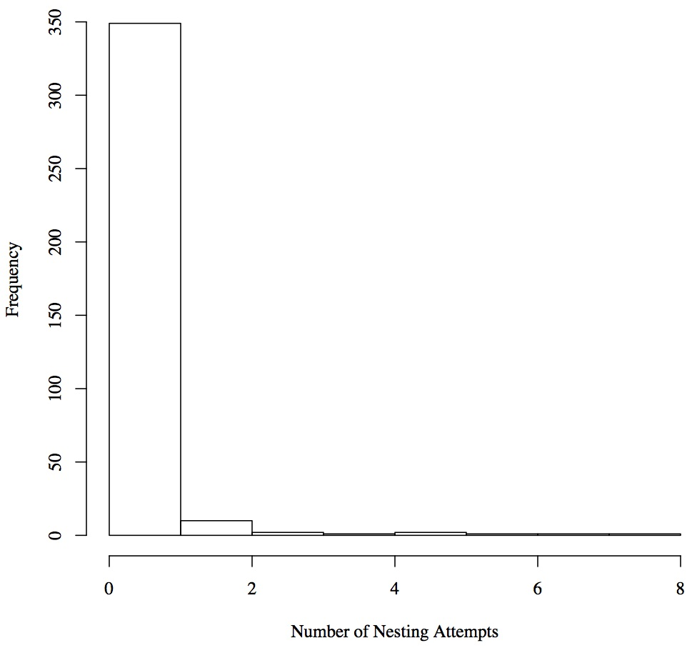
Figure S2. Distribution of the frequency of nesting attempts in a single box by House Wrens in each box.

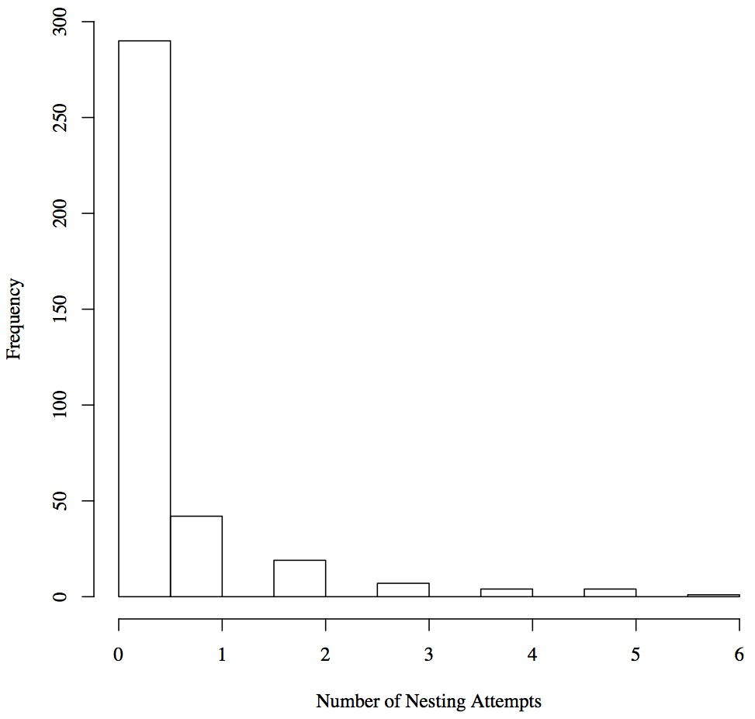
Figure S3. Distribution of the frequency of nesting attempts in a single box by Oak Titmice in each box.

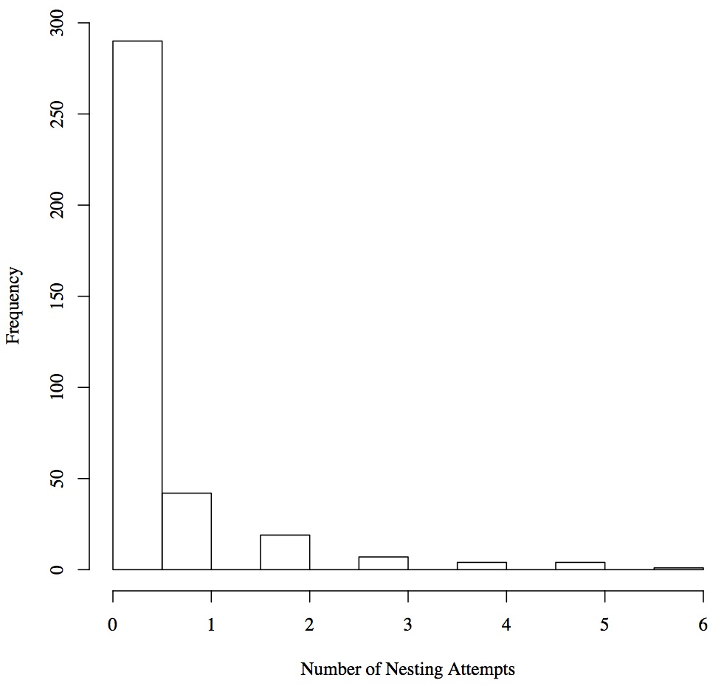
Figure S4. Distribution of the frequency of nesting attempts in a single box by Violet-green Swallows in each box.

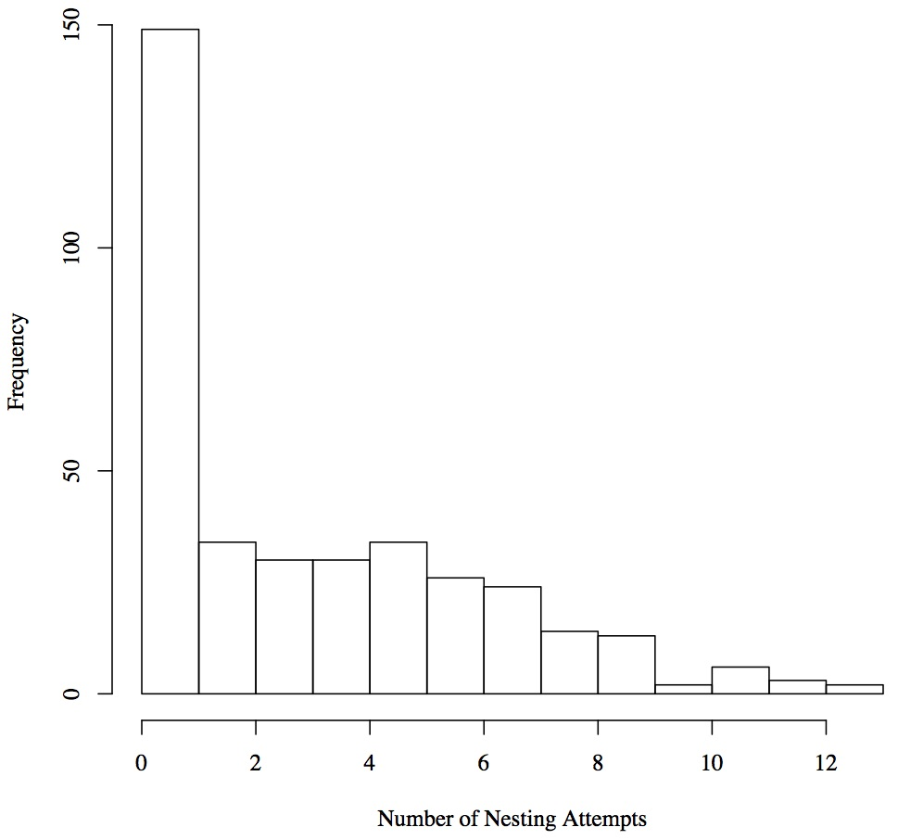
Figure S5. Distribution of the frequency of nesting attempts in a single box by Western Bluebirds in each box.

Table S1. Support for the final set of models predicting box occupancy for Ash-throated Flycatchers.

Model | k | ΔAIC_{c} | AIC_{c} w | Cumulative w | LL
Edge density + grassland | 5 | 0.00* | 0.59 | 0.59 | -746.32
Grassland | 4 | 1.78 | 0.24 | 0.83 | -748.21
Edge density | 4 | 2.82 | 0.14 | 0.97 | -748.73
Null | 3 | 6.25 | 0.03 | 1.00 | -751.45
*AIC_{c} = 1502.65

Table S2. Support for the final set of models predicting nesting success for Ash-throated Flycatchers.

Model | k | ΔAIC_{c} | AIC_{c} w | Cumulative w | LL
Occupancy rate | 4 | 0.00* | 0.63 | 0.63 | -471.85
Grassland + occupancy rate | 5 | 1.70 | 0.27 | 0.89 | -471.70
Edge density + grassland + occupancy rate | 6 | 3.57 | 0.11 | 1.00 | -471.63
Edge density + grassland | 5 | 193.30 | 0.00 | 1.00 | -567.50
Grassland | 4 | 196.59 | 0.00 | 1.00 | -570.14
Null | 3 | 203.38 | 0.00 | 1.00 | -574.54
*AIC_{c} = 951.71

Table S3. Support for the final set of models predicting fledging success for Ash-throated Flycatchers.

Model | k | ΔAIC_{c} | AIC_{c} w | Cumulative w | LL
Grassland + occupancy rate | 5 | 0.00* | 0.62 | 0.62 | -1459.93
Edge density + grassland + occupancy rate | 6 | 1.74 | 0.26 | 0.87 | -1459.79
Occupancy rate | 4 | 3.18 | 0.13 | 1.00 | -1462.52
Grassland | 4 | 140.59 | 0.00 | 1.00 | -1531.23
Edge density + grassland | 5 | 140.74 | 0.00 | 1.00 | -1530.30
Null | 3 | 143.47 | 0.00 | 1.00 | -1533.66
*AIC_{c} = 2929.87

Table S4. Support for the final set of models predicting box occupancy for House Wrens.

Model | k | ΔAIC_{c} | AIC_{c} w | Cumulative w | LL
Distance to stream + grassland | 5 | 0.00* | 0.60 | 0.60 | -337.91
Grassland | 4 | 1.99 | 0.22 | 0.82 | -339.91
Distance to stream | 4 | 3.26 | 0.12 | 0.93 | -340.54
Null | 3 | 4.37 | 0.07 | 1.00 | -342.10
*AIC_{c} = 685.84

Table S5. Support for the final set of models predicting nesting success for House Wrens.

Model | k | ΔAIC_{c} | AIC_{c} w | Cumulative w | LL
Occupancy rate | 4 | 0.00* | 0.50 | 0.50 | -245.18
Grassland + occupancy rate | 5 | 0.66 | 0.36 | 0.85 | -244.51
Distance to stream + grassland + occupancy rate | 6 | 2.45 | 0.15 | 1.00 | -244.40
Distance to stream + grassland | 5 | 90.30 | 0.00 | 1.00 | -289.33
Grassland | 4 | 91.31 | 0.00 | 1.00 | -290.84
Null | 3 | 93.60 | 0.00 | 1.00 | -292.98
*AIC_{c} = 498.38

Table S6. Support for the final set of models predicting fledging success for House Wrens.

Model | k | ΔAIC_{c} | AIC_{c} w | Cumulative w | LL
Occupancy rate | 4 | 0.00* | 0.58 | 0.58 | -1004.45
Grassland + occupancy rate | 5 | 1.36 | 0.30 | 0.88 | -1004.13
Distance to stream + grassland + occupancy rate | 6 | 3.14 | 0.12 | 1.00 | -1004.02
Grassland | 4 | 49.45 | 0.00 | 1.00 | -1029.17
Null | 3 | 49.65 | 0.00 | 1.00 | -1030.28
Distance to stream + grassland | 5 | 49.92 | 0.00 | 1.00 | -1028.41
*AIC_{c} = 2016.91

Table S7. Support for the final set of models predicting box occupancy for Oak Titmice.

Model | k | ΔAIC_{c} | AIC_{c} w | Cumulative w | LL
Mixed oak-madrone + chaparral + distance to stream + edge density | 7 | 0.00* | 0.40 | 0.40 | -510.11
Mixed oak-madrone + chaparral + distance to stream | 6 | 0.68 | 0.28 | 0.68 | -511.45
Grassland + distance to stream | 5 | 1.86 | 0.16 | 0.84 | -513.04
Mixed oak-madrone + grassland + distance to stream | 6 | 3.51 | 0.07 | 0.91 | -512.86
Chaparral + distance to stream | 5 | 4.15 | 0.05 | 0.96 | -514.19
Mixed oak-madrone + grassland + distance to stream + edge density | 7 | 4.74 | 0.04 | 1.00 | -512.48
Mixed oak-madrone + chaparral + edge density | 6 | 15.69 | 0.00 | 1.00 | -518.95
Mixed oak-madrone + distance to stream | 5 | 16.76 | 0.00 | 1.00 | -520.49
Edge density + distance to stream | 5 | 17.04 | 0.00 | 1.00 | -520.63
Distance to stream | 4 | 17.21 | 0.00 | 1.00 | -521.72
Grassland + edge density | 5 | 18.40 | 0.00 | 1.00 | -521.31
Mixed oak-madrone + grassland + edge density | 6 | 19.33 | 0.00 | 1.00 | -520.77
Chaparral + edge density | 5 | 19.72 | 0.00 | 1.00 | -521.97
Grassland | 4 | 20.37 | 0.00 | 1.00 | -523.30
Chaparral | 4 | 27.45 | 0.00 | 1.00 | -526.84
Mixed oak-madrone + edge density | 5 | 30.48 | 0.00 | 1.00 | -527.35
Mixed oak-madrone | 4 | 30.52 | 0.00 | 1.00 | -528.37
Edge density | 4 | 31.64 | 0.00 | 1.00 | -528.94
Null | 3 | 35.62 | 0.00 | 1.00 | -531.93
*AIC_{c} = 1034.24

Table S8. Support for the final set of models predicting nesting success for Oak Titmice.

Model | k | ΔAIC_{c} | AIC_{c} w | Cumulative w | LL
Mixed oak-madrone + chaparral + distance to stream + occupancy rate | 7 | 0.00* | 0.53 | 0.53 | -336.16
Mixed oak-madrone + chaparral + distance to stream + edge density + occupancy rate | 8 | 1.95 | 0.20 | 0.73 | -336.13
Occupancy rate | 4 | 2.09 | 0.19 | 0.92 | -340.21
Grassland + distance to stream + occupancy rate | 6 | 3.74 | 0.08 | 1.00 | -339.03
Grassland + distance to stream | 5 | 185.16 | 0.00 | 1.00 | -430.74
Mixed oak-madrone + chaparral + distance to stream + edge density | 7 | 185.32 | 0.00 | 1.00 | -428.82
Mixed oak-madrone + chaparral + distance to stream | 6 | 185.78 | 0.00 | 1.00 | -430.05
Null | 3 | 197.56 | 0.00 | 1.00 | -438.95
*AIC_{c} = 686.34

Table S9. Support for the final set of models predicting fledging success for Oak Titmice.
Model | k | ΔAIC_{c} | AIC_{c} w | Cumulative w | LL
Occupancy rate | 4 | 0.00* | 0.47 | 0.47 | -1332.06
Mixed oak-madrone + chaparral + distance to stream + occupancy rate | 7 | 1.12 | 0.27 | 0.74 | -1329.61
Mixed oak-madrone + chaparral + distance to stream + edge density + occupancy rate | 8 | 2.47 | 0.14 | 0.88 | -1329.28
Grassland + distance to stream + occupancy rate | 6 | 2.75 | 0.12 | 1.00 | -1331.43
Grassland + distance to stream | 5 | 111.94 | 0.00 | 1.00 | -1387.02
Null | 3 | 113.10 | 0.00 | 1.00 | -1389.61
Mixed oak-madrone + chaparral + distance to stream | 6 | 113.19 | 0.00 | 1.00 | -1386.65
Mixed oak-madrone + chaparral + distance to stream + edge density | 7 | 130.36 | 0.00 | 1.00 | -1394.23
*AIC_{c} = 2672.13

Table S10. Support for the final set of models predicting box occupancy for Violet-green Swallows.
Model | k | ΔAIC_{c} | AIC_{c} w | Cumulative w | LL
Distance to stream | 4 | 0.00* | 0.45 | 0.45 | -336.04
Distance to stream + chaparral | 5 | 1.39 | 0.23 | 0.68 | -335.73
Null | 3 | 1.58 | 0.21 | 0.88 | -337.83
Chaparral | 4 | 2.67 | 0.12 | 1.00 | -337.38
*AIC_{c} = 680.10

Table S11. Support for the final set of models predicting nesting success for Violet-green Swallows.
Model | k | ΔAIC_{c} | AIC_{c} w | Cumulative w | LL
Distance to stream + chaparral + occupancy rate | 6 | 0.00* | 0.41 | 0.41 | -186.54
Chaparral + occupancy rate | 5 | 0.89 | 0.26 | 0.67 | -187.99
Distance to stream + occupancy rate | 5 | 1.06 | 0.24 | 0.91 | -188.07
Occupancy rate | 4 | 2.97 | 0.09 | 1.00 | -190.03
Distance to stream | 4 | 104.63 | 0.00 | 1.00 | -240.86
Distance to stream + chaparral | 5 | 104.98 | 0.00 | 1.00 | -240.03
Null | 3 | 107.29 | 0.00 | 1.00 | -243.19
Chaparral | 4 | 107.57 | 0.00 | 1.00 | -242.33
*AIC_{c} = 385.10

Table 12. Support for the final set of models predicting fledging success for Violet-green Swallows.
Model | k | ΔAIC_{c} | AIC_{c} w | Cumulative w | LL
Distance to stream + occupancy rate | 5 | 0.00* | 0.35 | 0.35 | -533.70
Distance to stream + chaparral + occupancy rate | 6 | 0.26 | 0.31 | 0.66 | -532.83
Chaparral + occupancy rate | 5 | 1.27 | 0.19 | 0.84 | -534.34
Occupancy rate | 4 | 1.57 | 0.16 | 1.00 | -535.49
Null | 3 | 76.88 | 0.00 | 1.00 | -574.15
Distance to stream | 4 | 77.51 | 0.00 | 1.00 | -573.46
Chaparral | 4 | 78.35 | 0.00 | 1.00 | -573.88
Distance to stream + chaparral | 5 | 79.10 | 0.00 | 1.00 | -573.25
*AIC_{c} = 1077.42

Table S13. Support for the final set of models predicting box occupancy for Western Bluebirds.
Model | k | ΔAIC_{c} | AIC_{c} w | Cumulative w | LL
Oak woodland + grassland + distance to stream | 6 | 0.00* | 0.72 | 0.72 | -2178.19
Grassland + distance to stream | 5 | 3.24 | 0.14 | 0.87 | -2180.81
Oak woodland + chaparral + distance to stream | 6 | 3.51 | 0.13 | 0.99 | -2179.94
Oak woodland + grassland | 5 | 10.25 | 0.00 | 1.00 | -2184.32
Grassland | 4 | 11.19 | 0.00 | 1.00 | -2185.78
Oak woodland + chaparral | 5 | 21.89 | 0.00 | 1.00 | -2190.14
Oak woodland + distance to stream | 5 | 24.51 | 0.00 | 1.00 | -2191.45
Chaparral + distance to stream | 5 | 33.48 | 0.00 | 1.00 | -2195.93
Oak woodland | 4 | 37.44 | 0.00 | 1.00 | -2198.91
Chaparral | 4 | 44.25 | 0.00 | 1.00 | -2202.32
Distance to stream | 4 | 47.54 | 0.00 | 1.00 | -2203.96
Null | 3 | 55.19 | 0.00 | 1.00 | -2208.79
*AIC_{c} = 4368.39

Table S14. Support for the final set of models predicting nesting success for Western Bluebirds.
Model | k | ΔAIC_{c} | AIC_{c} w | Cumulative w | LL
Occupancy rate | 4 | 0.00 | 0.76 | 0.76 | -1552.25
Grassland + distance to stream + occupancy rate | 6 | 2.97 | 0.17 | 0.93 | -1551.73
Oak woodland + grassland + distance to stream + occupancy rate | 7 | 4.68 | 0.07 | 1.00 | -1551.58
Oak woodland + grassland + distance to stream | 6 | 345.95 | 0.00 | 1.00 | -1723.22
Grassland + distance to stream | 5 | 347.03 | 0.00 | 1.00 | -1724.76
Null | 3 | 372.98 | 0.00 | 1.00 | -1739.74
*AIC_{c} = 3112.50

Table S15. Support for the final set of models predicting fledging success for Western Bluebirds.
Model | k | ΔAIC_{c} | AIC_{c} w | Cumulative w | LL
Occupancy rate | 4 | 0.00 | 0.73 | 0.73 | -4933.84
Grassland + distance to stream + occupancy rate | 6 | 2.72 | 0.19 | 0.92 | -4933.20
Oak woodland + grassland + distance to stream + occupancy rate | 7 | 4.51 | 0.08 | 1.00 | -4933.09
Grassland + distance to stream | 5 | 279.31 | 0.00 | 1.00 | -5072.50
Oak woodland + grassland + distance to stream | 6 | 279.50 | 0.00 | 1.00 | -5071.59
Null | 3 | 305.76 | 0.00 | 1.00 | -5087.73
*AIC_{c} = 9875.70

Table S16. Significant variables for each species in each of the 3 analyses with estimated slopes indicated in parentheses.

Species | Occupancy | Nesting success | Fledging success
Ash-throated Flycatcher | Edge density (0.24)  Percentage of grassland  (-0.27) | Occupancy rate (0.87) | Occupancy rate (1.51)
House Wren | Percentage of grassland  (-0.69) | Occupancy rate (0.92) | Occupancy rate (2.32)
Oak Titmouse | Distance to stream (-0.75)  Percentage of chaparral (0.83)  Percentage of grassland  (-0.82) | Occupancy rate (1.03)  Percentage of  chaparral (0.32) | Occupancy rate (2.23)
Violet-green Swallow |  | Occupancy rate (1.75) | Occupancy rate (3.52)
Western  Bluebird | Distance to stream (0.29)  Percentage of chaparral  (-0.40)  Percentage of grassland (0.50) | Occupancy rate (0.32) | Occupancy rate (0.34)

