
Appendix S1
Winterberry Citizen Science Monitoring Project
Monitoring Protocol

Overview of citizen monitoring steps:
- Select a site
- Select plant species to investigate
- Select individual focal plants
- Mark your site and plants
- Record your observations of plants
- Report your data

1. Selecting a site

A site is the area which encompasses any plants you plan to observe. Select sites that are:
- convenient for you to get to
- relatively uniform habitat
- at least 12 m² in area, but not larger than 200m².

Try to avoid sites where you know people regularly pick berries (we are not tracking human use of berries). Remember, if the land is not publicly owned, be sure to secure permission from the landowner to observe plants on the property. Try to avoid:
- Steep slopes
- Very windy sites
- Areas prone to snow drifts
- Watered or fertilized sites

The size of your site will depend on how sparse the species you are observing are on the landscape and which species you are monitoring. If the plants are dense and you selected a small species, a small site will work, if the plants are sparse, a larger site will be necessary.

You will make your observations repeatedly at the same site or sites over time. You will want to somehow mark your site so that you can find it again in the future. For most sites, it is probably easiest to mark an easy entry point or nearby tree or shrub with colorful flagging, which is a colored non-adhesive tape often made of PVC or vinyl, scrap cloth, or something similar. You can also use natural or human-made landmarks, like the edge of a yard, large rocks, a bend in a trail, a road, or something similar to remember your site location.

When you've selected and marked your site(s), fill out the site description form so we can have the relevant data about your site. You'll need to record the latitude, longitude, and elevation of your site. You can do this with a GPS unit, or you can use Google Earth to locate the exact location of your site. Submit site information through our website using a google form, or email or fax it to us (list Christa Mulder as the recipient). See the first page for contact information.

2. Selecting a plant species to investigate
The focal species we are investigating are Vaccinium vitis-idaea (lowbush cranberry or lingonberry), Empetrum nigrum (crowberry), Rosa acicularis (prickly rose), and Viburnum edule (highbush cranberry). We selected these four species because they all retain a portion of their berries overwinter. You may choose just a single species to monitor, or you may choose more than one. However, for the data to be useful you must monitor the same species for at least 2 years.

Locate one or more of these species in a convenient location. You will be monitoring on weekly basis prior to snowfall, and every 2 weeks after snowfall. Take a look at the images below to identify your focal species. More detailed identification guides are provided on our website shortly (see link on the first page). If you are still unsure if you have the correct species, email us photos and we can make sure you have correctly identified your plants. Do this early on so you don’t collect data on the wrong species!
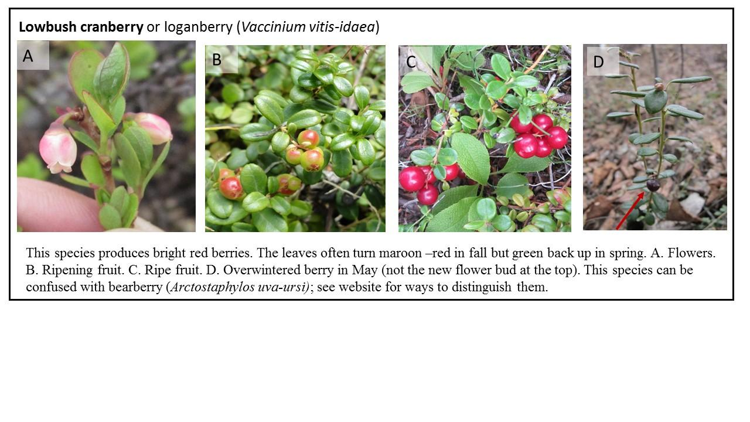
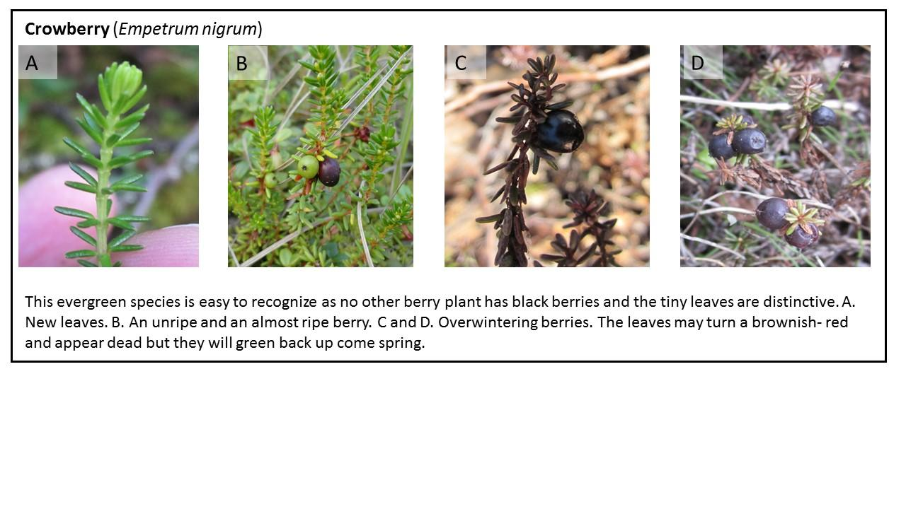

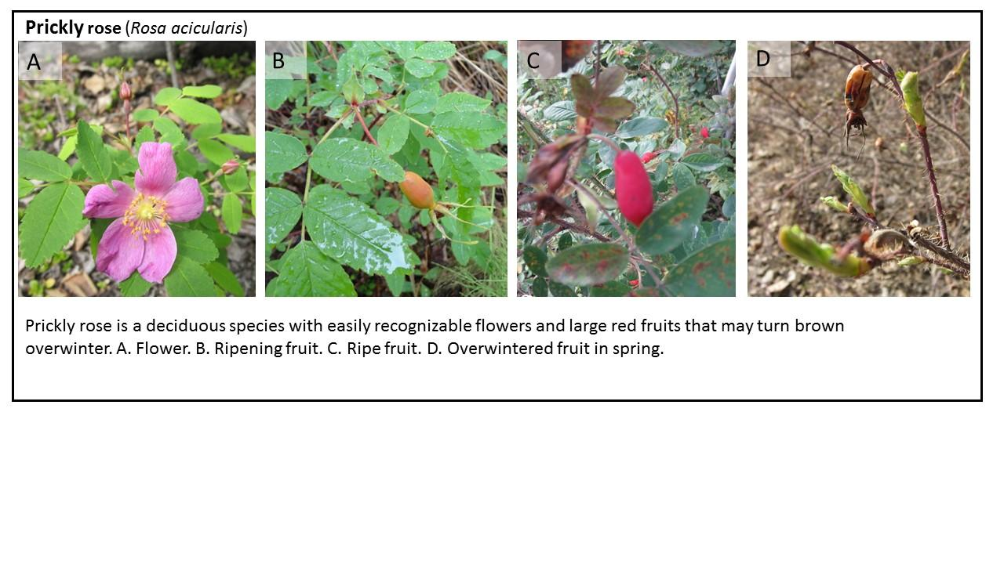

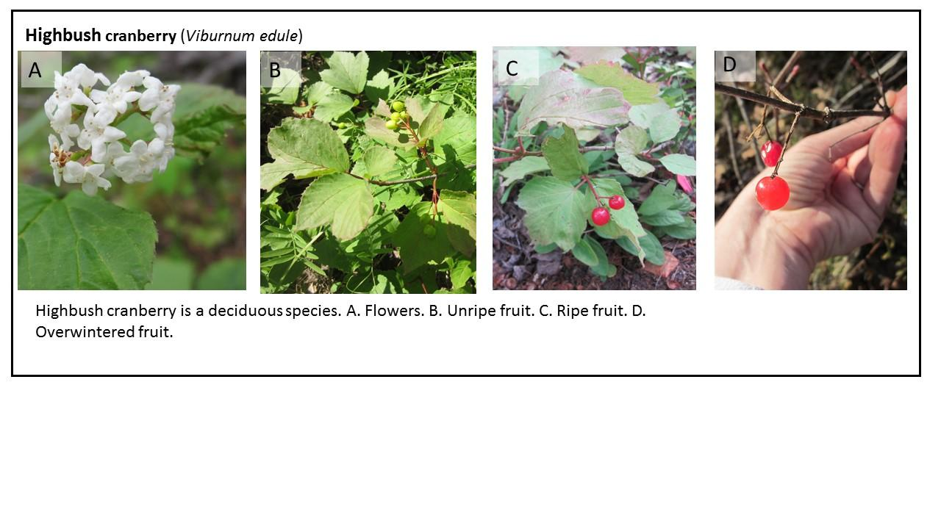

3. Selecting individual focal plants

We want to track enough berries that we can get a good idea of what happens to the average berry, but we don’t want them all on the same plant or too close together, because then a single event (e.g., a visit by a bear) could result in the loss of all the berries even though that is not representative of what is happening to all berries in the area. You will select and monitor ONE-HUNDRED berries on a minimum of TWENTY individuals of the same species at your site. Follow these rules:
- Choose twenty plants that are at least 5 strides (large steps) away from each other (if you are working on rose or high-bush cranberry) or at least 1 stride away from each other (if you are working on crowberry or low-bush cranberry). Make sure the plants are healthy and not close to a building.
- Count the number of berries on the plant. If there are 100 or more, stop there. If there are fewer, select more individuals until you have at least 100 berries. Do not pull berries off plants – you do not need exactly 100.

4. Marking focal plants

Because plant monitoring requires that you observe the same individual plants repeatedly, you will also need to mark each plant so that you can find it on each visit. Mark each individual plant with a unique label. We have supplied metal tags for this purpose. They are really simple to use: just write on them with anything (a pen, a pencil, a nail), and twist wires around the stem gently. You can simply number your plants (e.g., “rose 1, rose 2”) or give them individual names “Rockin’ Rose” “Royal Rose” etc.) We recommend that you also add a piece of bright flagging tape to the stem (for larger species) or a brightly painted popsicle stick next to the plant (for the two smaller species). This will save you a lot of time searching for your plants! Be sure to replace the labels if they get damaged by the weather or animals, so you can be continue collecting data for the correct plant.
- Tag each plant in such a way that all the berries you expect to track are above the tag. For some plants that might mean tagging quite far down the branches. Recount all your berries to make sure you have at least 100. If you don’t move the tag so you do, or add another plant.
- Because you are going to track berries even after they fall onto the ground (at least until the snow hits), you will need to make sure that there are no other berries they can get mixed up with. Look for berries on branches or plants that you did not tag, and remove them.

5. Recording Observations
- Start counting and monitoring once the first berries show some red or black color.

- Every week, count the number of berries on each marked plant or branch that are healthy (round) and unripe (green or partially colored), healthy and ripe (red or black), rotten (obvious mold or browning), or dried (shrivelled and dried out), rotten OR dried (but can’t tell which, this tends to happen late in the fall especially for rosehips) or damaged (tears, holes or shredding on the berry). If damaged, describe in the notes on the side or below check to see if you can find the culprit (e.g., caterpillars). Do not remove any berries still on the plant.

- Note any animal activity or sign or animals (e.g., fox poop stuffed with berries next to the plant). At a minimum, write down what you saw. You can go further and take pictures of the poop or other animal evidence. You can even use a stick or other object to spread the poop and take more pictures. DO NOT touch the poop with your hands, as there is a risk that you could get a disease from it.

- Once the snow starts to fall, assess whether you can continue to monitor. If there is only a light dusting you may be able to count berries without damaging the plants. However, don’t dig plants out from under the snow: you will likely just knock berries off the plant. Take a picture of your site in the snow and send it to us, along with a note that you have stopped collecting data.

- Once the snow melts, continue counting any berries remaining on the plant, and check underneath the plant for identifiable berries. Count the number of berries with and without brassies and add new brassies as needed.

- Stop counting berries once the plant flowers. Note that crowberry flowers very early and has tiny flowers! (See pictures on our website)

- The following fall, start again when the berries start to change color. You can use the same plants again, though you will need to check that there are enough berries – if not, move the tags or add plants. Because we are interested in differences in how berries are lost between years, for the data to be useful, we need the SAME species monitored for at least TWO years!
What if the plant I am observing dies?
- If the plant dies before the berries are all ripe or is removed from the site:
  - Select a new individual to monitor
  - Note the death in the comments section of the datasheet
  - Give the replacement plant a new, unique label (for example, plant #21)
- If the plant dies after the berries are all ripe (and the berries can still be tracked)
  - Continue as if the plant were still alive
  - However, do not reuse this plant the following year

6. Reporting your data.
- Submit data via our website.
- Contact us if you are having trouble entering data. You can scan and send your paper datasheets if you are having trouble.

Additional Training Resources:
https://sites.google.com/alaska.edu/winterberry/e-training
Resources include:
- Introduction to Winterberry Science
- How to Video 1: Selecting a Site and Species
- How to Video 2: Setting up Your Site
- How to Video 3: Making Observations
- How-to Video 4: Entering Data Online
- Quiz Yourself!

Please attend a live training or refresher training each year if you are able. If you are not able, please contact one of our staff.

Acknowledgements: This protocol was developed by C. Mulder and K. Spellman, with review by E. Sparrow and L. Parkinson. It was piloted by L. Parkinson and C. Mulder in Fairbanks, D. Baier in Dillingham, T. Mynatt and her K-2 students in Venetie, and D. Peterson and her 7-8th grade students in Fairbanks. This project is support through partnerships with the Bonanza Creek Long Term Ecological Research Program and the Arctic and Earth SIGNs program. Major funding is provided through a grant to the University of Alaska Fairbanks from the National Science Foundation, award 1713156 (PI: KV Spellman, CoPIs: CP Mulder and EB Sparrow).

