***Supplemental Materials***

Larson, E.R., L. Dornak, C.A. Underwood, C. Gronewold, J. Berglund, R. Schmitz, and B. Mandernack. 2024. Tree rings and aerial imagery illustrate a multi-century trend from open lands to closed forest at Eagle Valley, Southwest Wisconsin, USA. Natural Areas Journal 44(4).

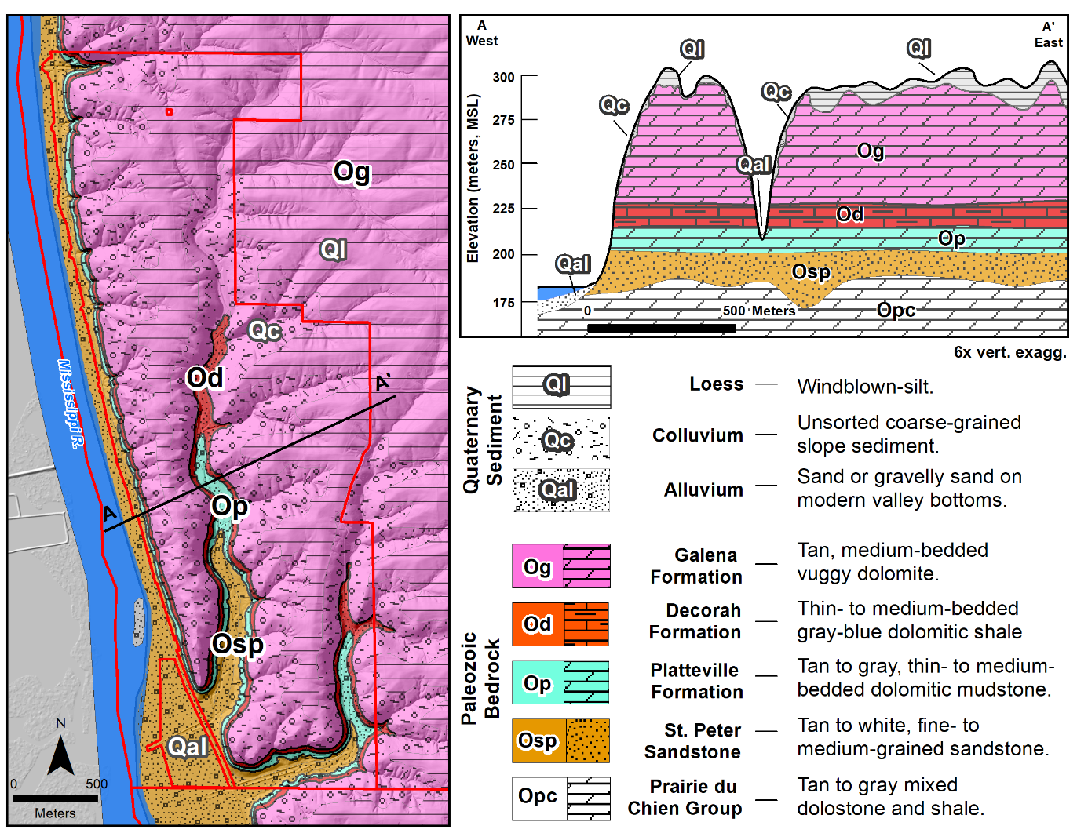

**Supplemental Figure S1**.Surficial sediment and bedrock geology map and cross-section of the Eagle Valley Nature Preserve. Surficial sedimentary geology from Carson (2012). Bedrock geology interpretation derived from Steinhilber et al. (1961), Mudrey et al. (1982), Stewart et al. (2022), and local well drilling logs (accessed through Wisconsin DNR Well Construction Information System, available: [https://dnr.wisconsin.gov/topic/Groundwater/Data.html], accessed 8/8/2023).

## Additional Background on the Geology of Eagle Valley Nature Preserve

The geology of Eagle Valley Nature Preserve is distinctive relative to much of the Upper Midwest of the United States and exemplifies the landscape that is referred to as the Driftless Region. The bedrock layers of central North America generally date to the Paleozoic Era or older (>300 million years ago) and in most places were altered by several major advances and retreats of continental glaciers during the Quaternary Period of the last 2.58 million years. In contrast, the Driftless Region was spared the depositional and scouring effects of one or more of these glacial advances, resulting in a rugged topography with high-relief incised valleys, thin sediments, and frequent bedrock outcrops. Early European settlers to the region noted the striking juxtaposition of these high-relief valleys and hills relative to the surrounding low-relief glacial plains, and due to the general absence of glacial drift established the term “Driftless Area,” a loosely defined boundary which encompassed most of southeast Minnesota, southwest Wisconsin, northeast Iowa, and northwest Illinois (Chamberlin and Salisbury 1886). Despite later observations of evidence for widespread glacial drift from older pre-Illinoisan Glaciations (>500,000 years ago) in southeast Minnesota, northeast Iowa, and the southwest edge of Wisconsin, including the land around Eagle Valley Nature Preserve, this term has remained ingrained in both the culture and science of the region. More recently, researchers have formally defined this boundary based on the mapped absence of glacial drift, resulting in a smaller, geologically-defined Driftless Area (Carson et al. 2023). Surrounding areas which contain drift, yet still resemble the landscape typified by the sparing of glacial action due to the large amount of time and erosion that has occurred since their effects are now referred to as areas of “Driftless-style” topography. We hereafter refer to the combined formal Driftless Area and “Driftless-style” area as the Driftless Region in recognition of the cultural and scientific importance and history of this term.

The rugged topography of the lands within Eagle Valley Nature Preserve exemplifies classic Driftless Region geology; a thin cover of unconsolidated Quaternary sediments atop deeply bisected Paleozoic sedimentary bedrock. Along the ridgetops and plateaus where relief is most gentle exists a thin (<10 m thick) layer of Quaternary loess; wind-blown silt locally comprised of the Peoria, Roxana, and Loveland Members of the Keiler Formation (Carson 2012). Flanks of the valleys where slopes are greatest contain Quaternary colluvium; unsorted coarse-grained sediments derived from weathered Paleozoic bedrock and upland loess transported by gravity. At the bottoms of stream valleys is Quaternary alluvium; stream-deposited sand or gravelly sand, often overlain by a thin layer of peat or silty overbank sediments. The bedrock underlaying these thin sediments consists of a sequence of relatively flat-lying Paleozoic sedimentary units of Ordovician age (Steinhilber et al. 1961, Mudrey et al. 1982, Stewart et al. 2022). The uppermost unit is the Galena Formation, a tan, medium-bedded vuggy dolomite, with some sandy layers at higher elevation and cherty layers at lower elevation. Due to the thickness of the Galena Formation (upwards of 60 m thick), it is the primary bedrock unit encountered near the surface in the study area, in particular at higher elevations. Below the Galena Formation is the Decorah Formation, a thin- to medium-bedded gray-blue dolomitic shale which often contains fossiliferous layers, and is overall about 10 m thick and typically exposed on the flanks of the bisected stream valleys. Below the Decorah is the Platteville Formation, a tan to gray, thin- to medium-bedded dolomitic mudstone and limestone, locally about 15 m thick, and also exposed along stream valley walls. Below the Platteville is the St. Peter Sandstone, a tan to white, fine- to medium-grained sandstone, often cross-bedded and poorly cemented. The St. Peter Sandstone outcrops at the lowest elevations in the study area and varies from 15–30 m thick. Beneath the St. Peter Sandstone is the Prairie du Chien Group, a tan to gray mix of dolostone and shale which does not outcrop in the study area.

The Galena Formation is the principal ore-bearing rock unit throughout the Upper Mississippi Valley Zinc-Lead District (Heyl Jr. et al. 1956), owing its name to Galena, Illinois, which in turn owes its name to the lead-sulfide mineral galena which can be found within the formation. Hydrothermal fluids which rose through fractures and solution openings within the bedrock deposited galena as mineral veins, along with other minerals such as sphalerite (ZnS), marcasite (FeS2), pyrite (FeS2), and calcite (CoCO3). Over time as the Galena Formation weathered away, the relatively oxidation-resistant galena would concentrate in the residual soil above these mineral deposits to form what is known as “float” (Broughton 1991). Early galena mining then simply involved digging shallow pits into the soil in order to collect the float, leading to the term lead “digs” or “diggings” to describe these mining sites, and resulting in landscapes pockmarked with shallow pits referred to as “badger holes.” As a concentration of galena in residual soils was a good indication of the presence of mineral-filled veins in the bedrock below, digs would also be the sites of exploratory drilling in order to discover mineral-filled crevices, flats, and pitches (Supplemental Figure 2). Historical records from the region indicate the presence of several former lead digs and mine shafts within the Eagle Valley Nature Preserve (Pepp et al. 2019), with on-site evidence discussed further in this paper.

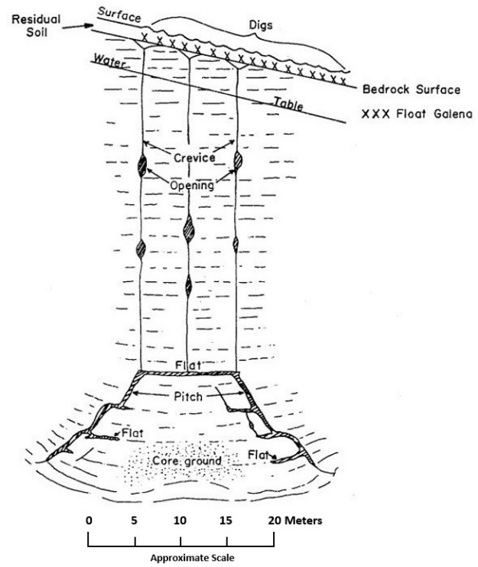

**Supplemental Figure S2**.Diagrammatic section showing the relationship between pitch, flat, crevice, opening, and residual “float” galena deposits and surface lead digs. An alteration of Figure 64 in Flint and Brown (1956).

**Supplemental Figure S3.** Climograph for Guttenburg, Iowa, observed immediately across the Mississippi River and less than 3 km from Eagle Valley (USHCN 2019). Mean monthly temperature and mean monthly precipitation from 1949–2020 are shown, with whiskers extending to 5th and 95th percentiles.

**Supplemental Figure S4.** The primary species of interest, bur oak (*Quercus macrocarpa*), white oak (*Q. alba*), and eastern redcedar (*Juniperus virginiana*), were found in different settings; (a) bur and white oak trees exhibiting “wolf tree” characteristics of an open-grown canopy now overgrown by younger trees were located across the Eagle Valley property, while (b) redcedars and remnant stumps (small and in the foreground) were generally located among rock outcrops overlooking the Mississippi River.

**Supplemental Figure S5.** The map and introductory matters for the General Land Office Survey of Township 4N Range 6W of the Northwest Territory, conducted in April of 1832. The featured quote overlaying the survey notes describes the surveyor’s entry into the land now referred to as Eagle Valley.

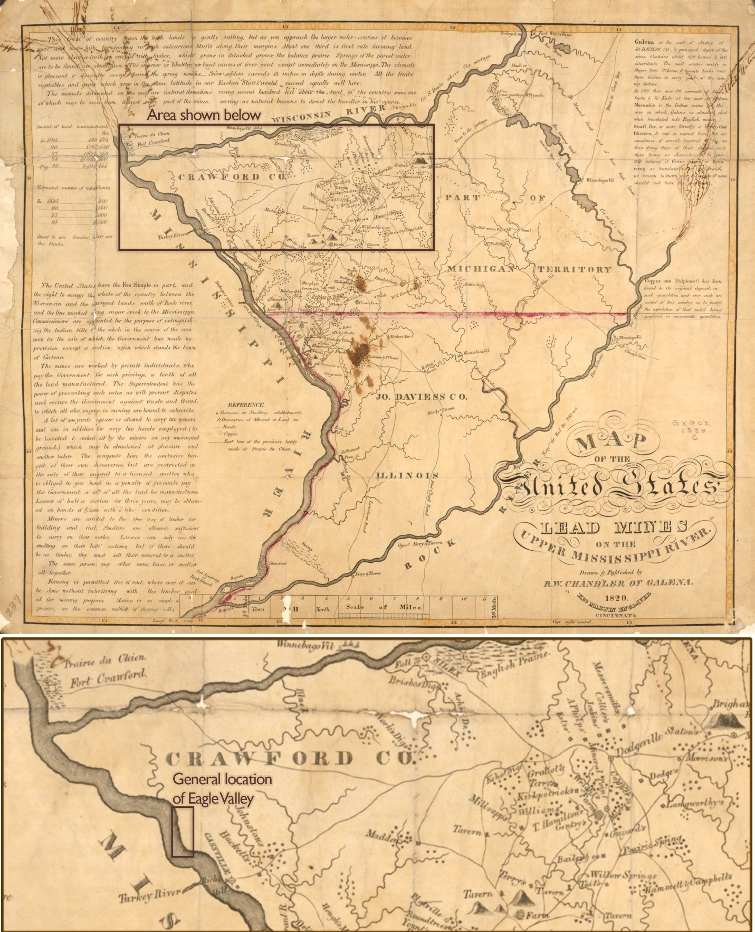

**Supplemental Figure S6.** A map of the lead mining district of the Upper Mississippi River in 1829 depicts the locations of early lead mining activity across the Driftless Region (Chandler 1829). Relative to Eagle Valley, lead mines are evident to the northeast of Cassville in the area around what is now Beetown, Wisconsin. Furthermore, text in the margin of this map states that “Miners are entitled to the free use of timber for building and [to] fuel smelters…” and that “Farming is permitted free of rent, wherever it can be done without interfering with the timber needed for mining purposes.” In other words, miners had an unrestricted freedom of action on the land *before* the GLO surveys were conducted in Wisconsin. This map stands as an important reminder of widespread impacts from European colonization already occurring at the time of the surveys.

Literature Cited

Broughton, W. A. 1991. Zinc and Lead Reserves of Southwest Wisconsin and The Undrilled Lead Digs of Southwest Wisconsin. Wisconsin Geological and Natural History Survey Open-File Report 91-5, Madison, Wisconsin.

Carson, E. C. 2012. Preliminary Quaternary Geology of Grant County, Wisconsin. Wisconsin Geological and Natural History Survey Open-File Report 2012-06, Madison, Wisconsin.

Carson, E. C., B. B. Curry, P. J. Kerr, and B. A. Lusardi. 2023. The Driftless Area: The extent of unglaciated and similar terrains in Wisconsin, Illinois, Iowa, and Minnesota. Wisconsin Geological and Natural History Survey, Educational Series 057, Madison, Wisconsin.

Chamberlin, T. C., and R. D. Salisbury. 1886. Preliminary paper on the driftless area of the upper Mississippi Valley. Government Printing Office, Washington, D.C.

Chandler, R. W. 1829. Map of the United States Lead Mines on the Upper Mississippi River. R.W. Chandler of Galena, Galena.

Flint, A. E., and C. E. Brown. 1956. Exploratory drilling of geologic structures for evidences of zinc and lead ore in Dubuque County, Iowa. U.S. Geological Survey Bulletin 1027-K:471–499.

Heyl Jr., A. V., A. F. Agnew, E. Lyons, C. H. Behre Jr., and A. E. Flint. 1956. The Geology of the Upper Mississippi Valley Zinc-Lead District. U.S. Geological Survey Professional Paper 309, Washington, D.C.

Mudrey, M. G., B. A. Brown, and J. K. Greenburg. 1982. Bedrock Geologic Map of Wisconsin (1:1,000,000 scale). Wisconsin Geologic and Natural History Survey, Madison, Wisconsin.

Pepp, K., G. Siemering, and S. Ventura. 2019. Digital Atlas of Historic Mining Activity in Southwestern Wisconsin. University of Wisconsin-Madison Extension, Madison, Wisconsin.

Steinhilber, W. L., O. J. Van Eck, and A. J. Feulner. 1961. Geology and ground-water resources of Clayton County, Iowa. The State of Iowa, Des Moines, Iowa.

Stewart, E. D., S. Mauel, G. E. Graham, and E. C. Carson. 2022. Geologic map of the Bloomington and Brodtville 7.5-minute quadrangles, Grant County, Wisconsin. Wisconsin Geological and Natural History Survey Open-File Report 2022–03, Madison, Wisconsin.

USHCN. 2019. U.S. Historical Climatology Network. Available: [<http://cdiac.ornl.gov/epubs/ndp/ushcn/newushcn.html>].